Working With Data DATA9910
Lucas Rizzo
email: lucas.rizzo@tudublin.ie

- TO DO: check out PHD options with Lucas!! – l
- http://lucasrizzo.com/
- https://lucasrizzo.com/index.php?action=proposal
- Contact = lucas.rizzo@tudublin.ie (outside of class hours)

Week 1 – Set up Environment and R Notebook

Intro

About me
- TU Dublin lecturer since 2020.
- MSc coordinator. Any questions about dissertation proposals give me a shout or check the MSc dissertation website.
- I’m from Belo Horizonte - Brazil and I have been living in Dublin since 2015.
- My research focus is on Artificial Intelligence, more specifically automated reasoning and computational models of argument.
- If you are interested in these topics you can have a look at my website.

Lectures
- Full-time programme TU059
  - Mondays 16:00-18:00
  - Wednesdays 11:00-13:00
  - All classes and labs onsite (unless otherwise stated)
- Part-time programme TU060 and Data Science Certificate TU256
  - Thursdays 18:00-22:00
  - Onsite CQ007 (and mirror online) Week 1, Week 6, and Week 13
  - Online classes, Week 2-5, Week 7-12

Communication Statement

- Outside class hours, we should communicate primarily through email: lucas.rizzo@tudublin.ie
- You can send me emails any time, and it should be answered in 1 or 2 days maximum.
- Pay attention to emails and announcements for this module in Brightspace! That is how I will let you know about updates or any recent changes in the module.

Online material
- Materials available through Brightspace
- Search for Working with Data DATA9910
  - Lecturer Lucas Rizzo
  - Be sure to enroll in the right programme, TU059 or TU060/256 as in the description of the course.

Reading list - Essential
- Essential Reading:
  - Wickam & Grolemund, R for Data Science, O’Reilly Press, 2016. Free at https://r4ds.had.co.nz/
  - Andrew O. Finley, Jeffrey W. Doser, Vince Melfi, R Programming for Data Sciences. 2020. Free at https://bookdown.org/rdpeng/rprogdatascience/
  - McKinney, Wes. Python for data analysis: Data wrangling with Pandas, NumPy, and IPython. " O'Reilly Media, Inc.", 2022. Open access HTML https://wesmckinney.com/book/

Reading list -Supplemental

Supplemental Reading:
- Bruce, Peter, Andrew Bruce, and Peter Gedeck. Practical statistics for data scientists: 50+ essential concepts using R and Python. O'Reilly Media, 2020 -
001.422 BRU
  - (for those who need a detailed introduction to essential concepts in statistics)
- Rafael C. Gonzalez, Richard E. Woods., Digital image processing, Pearson, 2017
  - (for those interested in getting in-depth knowledge of image data)
- Sweigart, Automate the Boring Stuff with Python, No Starch Press, 2019
  - (for those unfamiliar with Python)
- Beaulieu, Learning SQL, O’Reilly Media, 2020 Hands on Programming with R: free here
  - (for a more practical approach learning R)
- Beaulieu, Learning SQL, O’Reilly Media, 2020
  - (for those unfamiliar with SQL)d

Tech Stack

Python |  | R
pandas | requests | devtools | Rraven
matplotlib | scikit-image | warbleR | maps
numpy | os | ggplot2 | tuneR
sqlalchemy | scipy | lattice | seewave
psycopg2-binary |  | readr | signal
sqlalchemy_schemadisplay |  | rvest | audio
pillow |  | DBI | odbc
ipython |  | RPostgres | blob
jupyterlab |  | dplyr | titanic
seaborn |  | dbplyr | rlang

PostgreSQL
- Pgadmin4 (GUI)
- PostgreSQL server
Notebooks
- Jupyter (.ipynb)
- R (.rmd)
Data Camp 
- You can access DataCamp courses for extra practice (that is highly recommended)
- Please create an account with the @mytudublin.ie domain to have free access to all courses through the link below
Link to register on DataCamp
- Some courses that might help you in the first weeks (not all there is covered in this module):
  - Intro to Python for Data Science
Intermediate Python
- Introduction to R
- Introduction to importing data to R
- Web scraping in R

Recordings

- Recorded lectures (if recorded) are available in Brightspace.
  - Go to Module Tools > Virtual Classroom
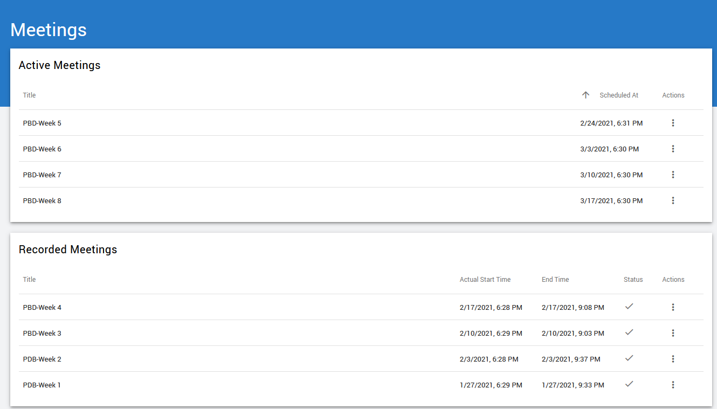#

Content

- Foundational module for data science

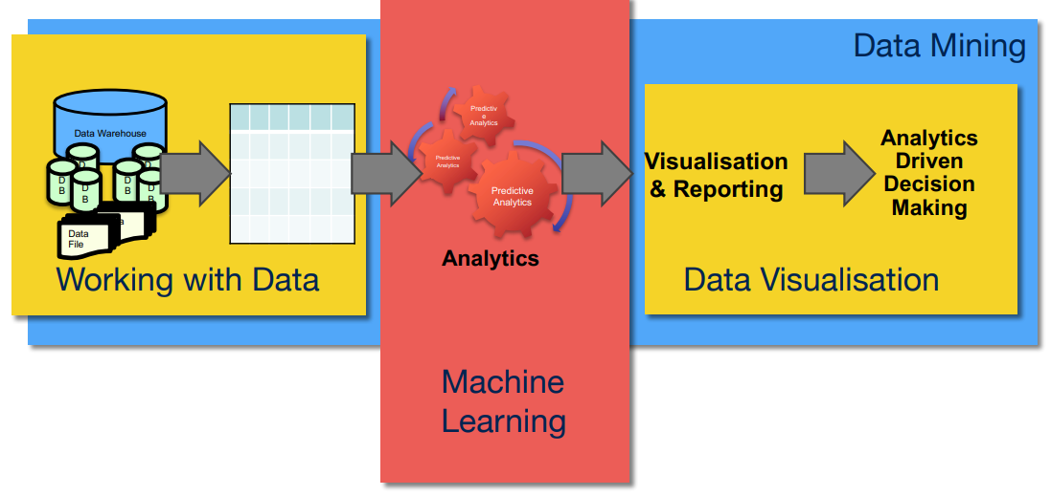
Eamonnk -Not sure what the above means

Assessment

- Lab assignments (40%). Some labs are marked and will need to be submitted
  - SQL programming and data centric languages (Python/R) (20%) (Week 5)
  - Image data lab (10%) (Week 10)
  - Audio data lab (10%) (Week 11)
- Continuous assessment (60%). Week 13
  - Select a dataset and create a notebook (data collection, cleaning, merging and some visualisation)

Indicative schedule

Week 1 | Set up environment and R notebook
Week 2 | Review Python and practice
Week 3 | Review R  Importing data with R
Week 4 | Intro SQL and aggregate queries
Week 5 | Databases and scripting languages (To be submitted)
Week 6 | Interpreting Data (summary statistics, data visualisation)
Week 7 | Review week
Week 8 | Data manipulation in R  Pandas and Numpy
Week 9 | Data visualisation in Python  Data processing (regular expressions)
Week 10 | Audio data (R and tuneR) (To be submitted)
Week 11 | Image data (Python and skimage) (To be submitted)
Week 12 | Time series (Python and Pandas)
Week 13 | Working on Assignment  Assignment deadline

This week Tasks

- Download and Set Up R and R-Studio
- Download and Set Up Python and Jupyter Notebook (see slides)
- Explore the Sample R Notebook File

Questions?

Content

Installing Python
- There are lots of ways to install Python. I recommend the official installer or Anaconda.
- If you already have Python installed check your version by opening a terminal and running
  - >>python --version
  - It should show something starting with 3
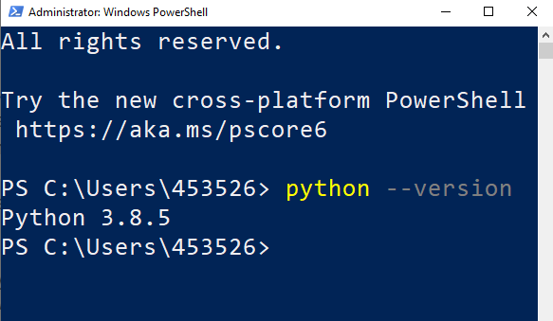

Installing on Windows

- Download Python from https://www.python.org/downloads
- Make sure you check the option to Add Python to your PATH
- Once the installation is
complete, open up a
terminal and check
your version as
shown previously

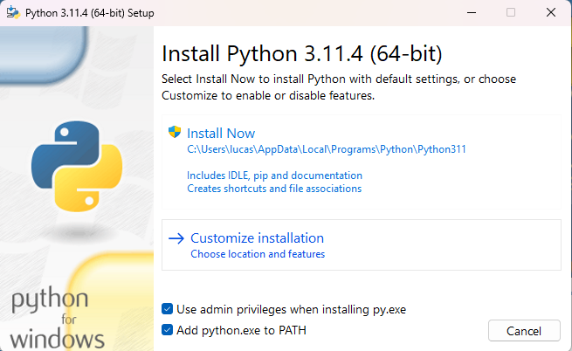

Installing on Mac / Ubuntu

- Newer versions of MacOS ship with Python 3 by default
- If you’re running MacOS and don’t have python head to the downloads page on the official website to install it
  - https://www.python.org/downloads/
- Python 3 can be installed on Ubuntu using apt
  - >>sudo apt install python3.11

PIP

- PIP is a package manager for Python packages, or modules if you like.
  - If you have Python version 3.4 or later, PIP is included by default.
- A package contains all the files you need for a module.
  - Modules are Python code libraries you can include in your project.
- Check if PIP is Installed
  - >>pip --version
- If you don’t have it, follow this guide https://pip.pypa.io/en/stable/installation/
- To install a Python package open a terminal and run
  - >>pip install <package name>
- For example, to install numpy you would run
  - >>pip install numpy
- More info commands using PIP here
  - https://www.w3schools.com/python/python_pip.asp

Notebooks

- Notebooks are interactive documents that allow you to combine code, text, and multimedia elements into a single file.
- It makes commenting your code much easier and allows you to interactively edit the code and run it from your web browser (if you want)
- In this course we will be using them for basically everything (studying, assignments, labs, etc.)
- We will be using two types of notebooks:
  - Jupyter Notebooks (.ipynb file extensions) that can handle Python and R kernels.
  - R Markdown notebooks (.rmd file extension) that can only handle R kernel.
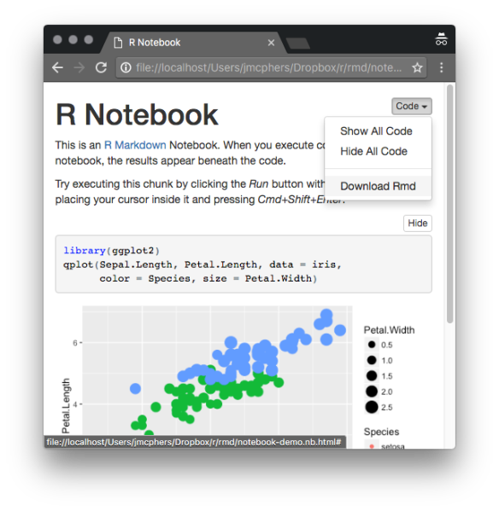

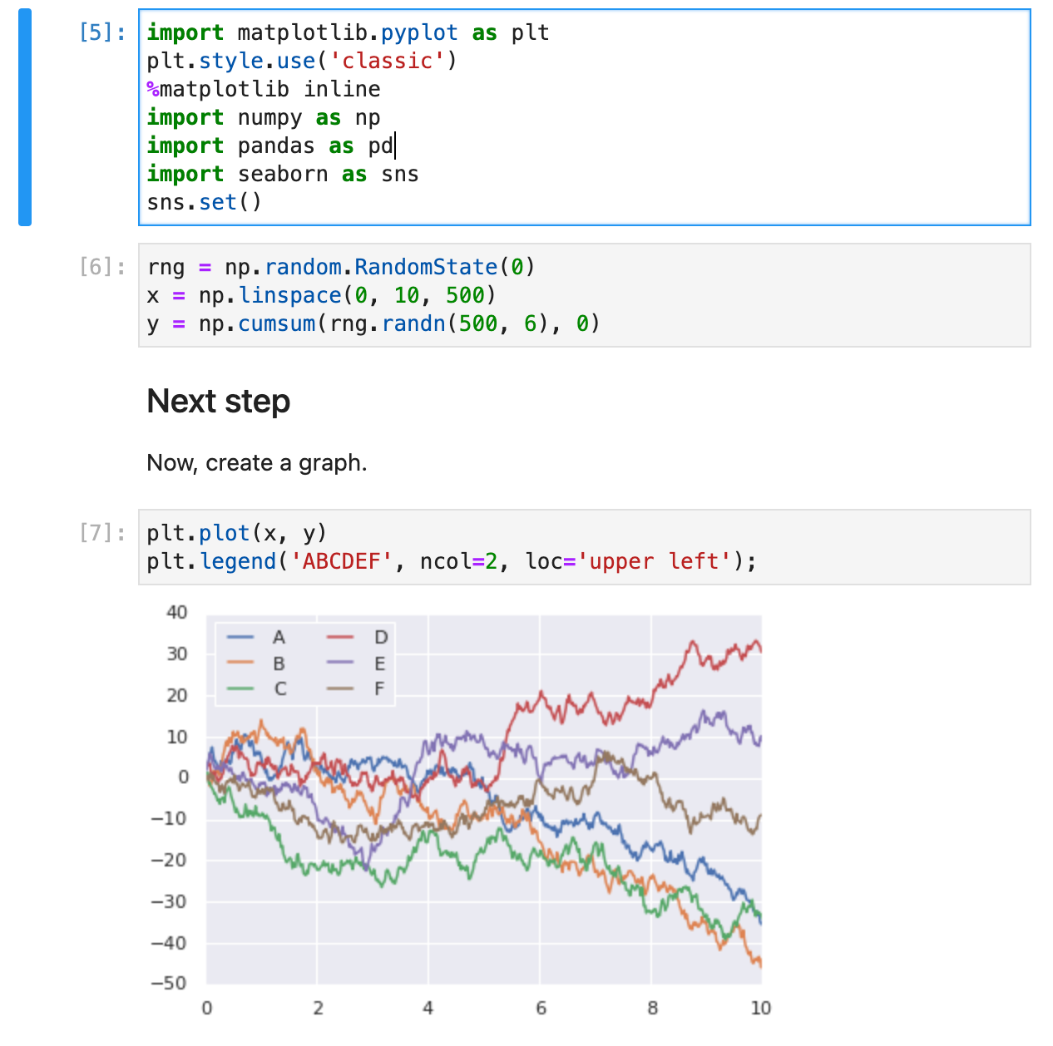

Installing Jupyter - 1

- Jupyter Notebook is a software that lets you combine text markdown with Python/R code
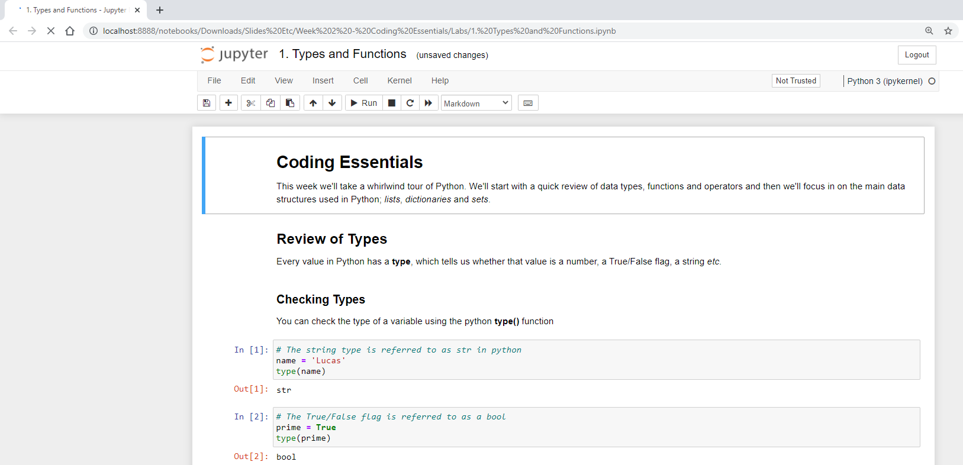

Installing Jupyter - 2
- You can install Jupyter using pip (but the module is actually called notebook)
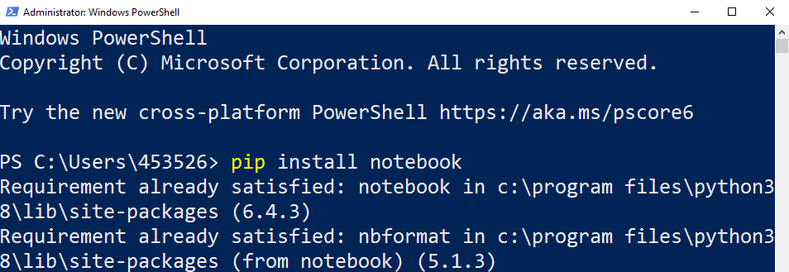

Installing Jupyter with Anaconda 
- You can use Anaconda to help you manage Python open-source packages.
- Anaconda is a Python/R data science distribution that contains conda, a package and environment manager, which helps you manage open-source packages available to them.
- It is good if you want to manage several Python/R environments, with different versions and packages. It also gives you a better interface to handle your packages.
- The main issues are that it can be very slow when updating and installing packages and R packages might be harder to find.

Anaconda 

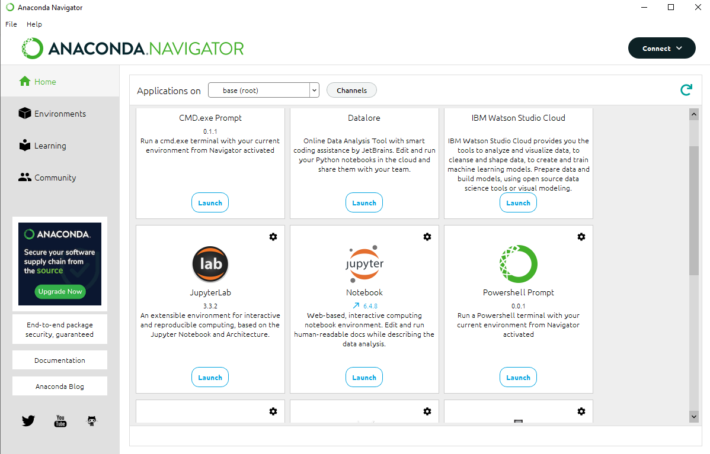
- Detailed instructions, including other operating systems, can be found here (it should be easy). > https://docs.anaconda.com/anaconda/install/
- You can check Anaconda starter guide > https://docs.anaconda.com/free/anacondaorg/user-guide/getting-started/
- Conda cheat sheet > https://docs.conda.io/projects/conda/en/4.6.0/_downloads/52a95608c49671267e40c689e0bc00ca/conda-cheatsheet.pdf

Using Jupyter Notebook (from command line)
- To start jupyter open a terminal and switch to the directory containing your code and run the notebook command
- For example, if your code is in a folder called Python in your home directory
  - >> cd Python
  - >> jupyter notebook
OR
>> python -m notebook
- A browser should open automatically but if not copy and paste the link shown in the terminal
- When you’re finished, you can stop jupyter by pressing control + c
- If you need to install a package using pip you may need to stop and restart the jupyter notebook for the changes to come through

Starting Jupyter Notebook (from command line)

- If a browser doesn’t automatically open, copy and paste one of the URLs highlighted
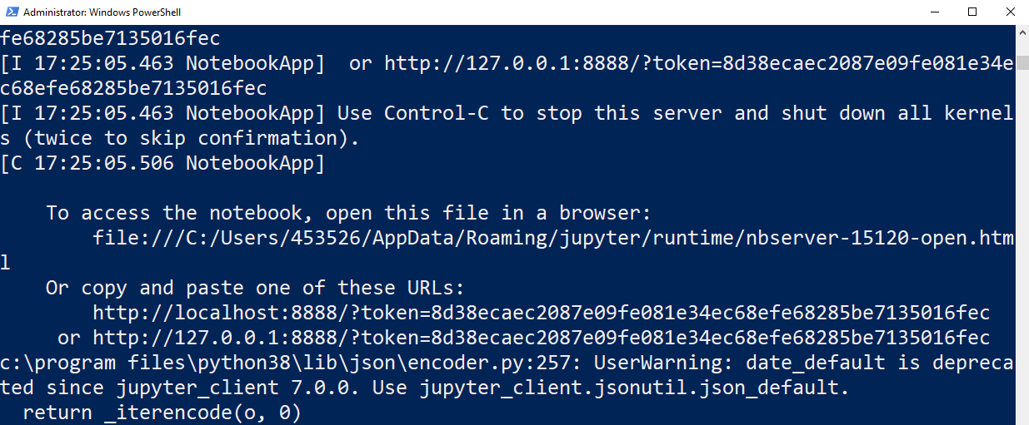

Starting Jupyter Notebook (with Anaconda)


Starting Jupyter Notebook
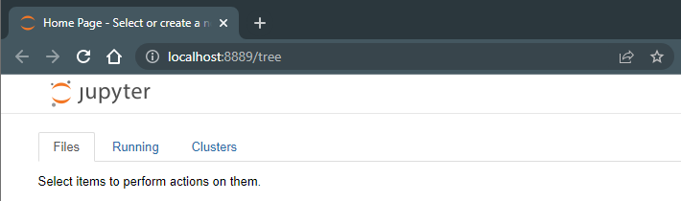

VSCode
- VSCode can also handle .ipynb files
- If you want to use it follow the tutorial here to start working with notebooks.> https://code.visualstudio.com/docs/datascience/jupyter-notebooks
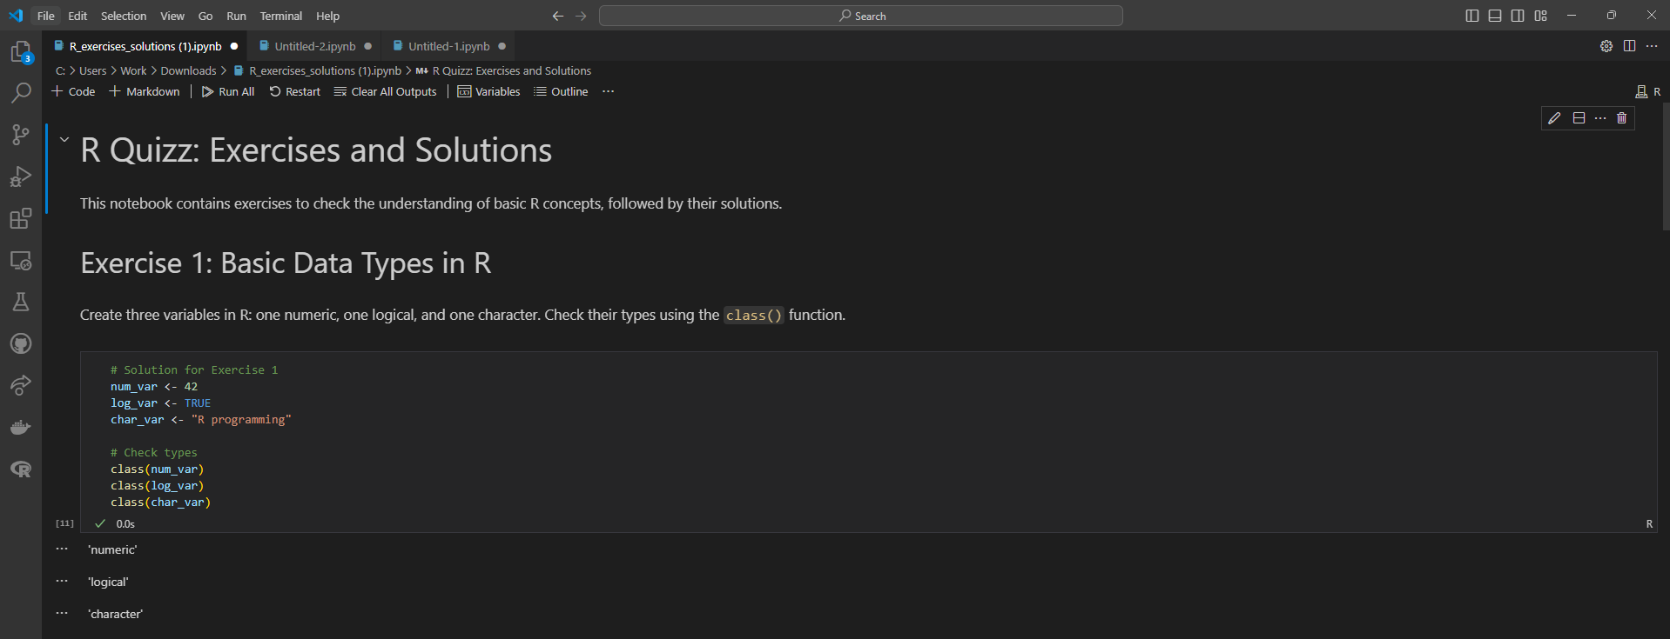

Markdown Cells
- Jupyter notebooks consist of blocks of code (called cells). Each cell can be either code or markdown (dropdown at the top of the screen)
- Jupyter uses GitHub markdown for the text cells.
- Markdown is a simple text-based formatting system
- For a full list of markdown commands see this web-page > https://github.com/adam-p/markdown-here/wiki/Markdown-Cheatsheet
- When you edit a cell you will see the markdown source code, run the cell to see the formatted output

Code cells
- Code cells let you run Python/R code (depending on the chosen kernel) and show you the output directly underneath
- Variables can be shared between cells (provided you run them in the correct order).
- Before submitting a notebook select the option to restart kernel and run all cells to make sure it will work for another user running your notebook (when you’re working ad-hoc it’s easy to get the order wrong)
Eamonn – important below when submitting

Submitting Notebooks – Important!!
- Make sure you run your code before saving your notebook for submission
- If you’re using external files, include them in the notebook folder and use a relative path, for example
  - > I = cv2.imread(‘image.jpg’)
Not
> I = cv2.imread(‘C:\Users\453526\Python\image.jpg’)
- When you’re finished, save the notebook, and zip the entire folder including any external files you used
- Your instructor should be able to restart kernel and run all cells without making any edits

Downloading and Installing R (from scratch)

- R is another base language you’ll be using.
- It is “a free software environment for statistical computing and graphics”. By itself, R is just a programme which will read in and execute a script.
  - Open an internet browser and go to www.r-project.org
    - Times out >>> use https://cran.r-project.org
    - List of mirrors > https://cran.r-project.org/CRAN_mirrors.csv
    - use this >>> https://cloud.r-project.org/
      - It auto re-directs to a working mirror
  - Click the "download R" link in the middle of the page under "Getting Started."
  - Select a CRAN location (a mirror site) and click the corresponding link.
  - Click on the "Download R for Windows" link at the top of the page.
  - Click on the "install R for the first time" link at the top of the page.
  - Click "Download R for Windows" and save the executable file somewhere on your computer. Run the .exe file and follow the installation instructions.
  - Now that R is installed, you need to download and install RStudio.

RStudio (from scratch)

- RStudio is a very nice Integrated Development Environment (IDE) which makes writing R programmes a joy. This isn’t necessary but highly recommended!
  - Go to https://posit.co/download/rstudio-desktop/ and click on the "Download RStudio" button.
  - Click on "Download RStudio Desktop."
  - Click on the version recommended for your system, or the latest Windows version, and save the executable file. Run the .exe file and follow the installation instructions.

R and RStudio (Anaconda)

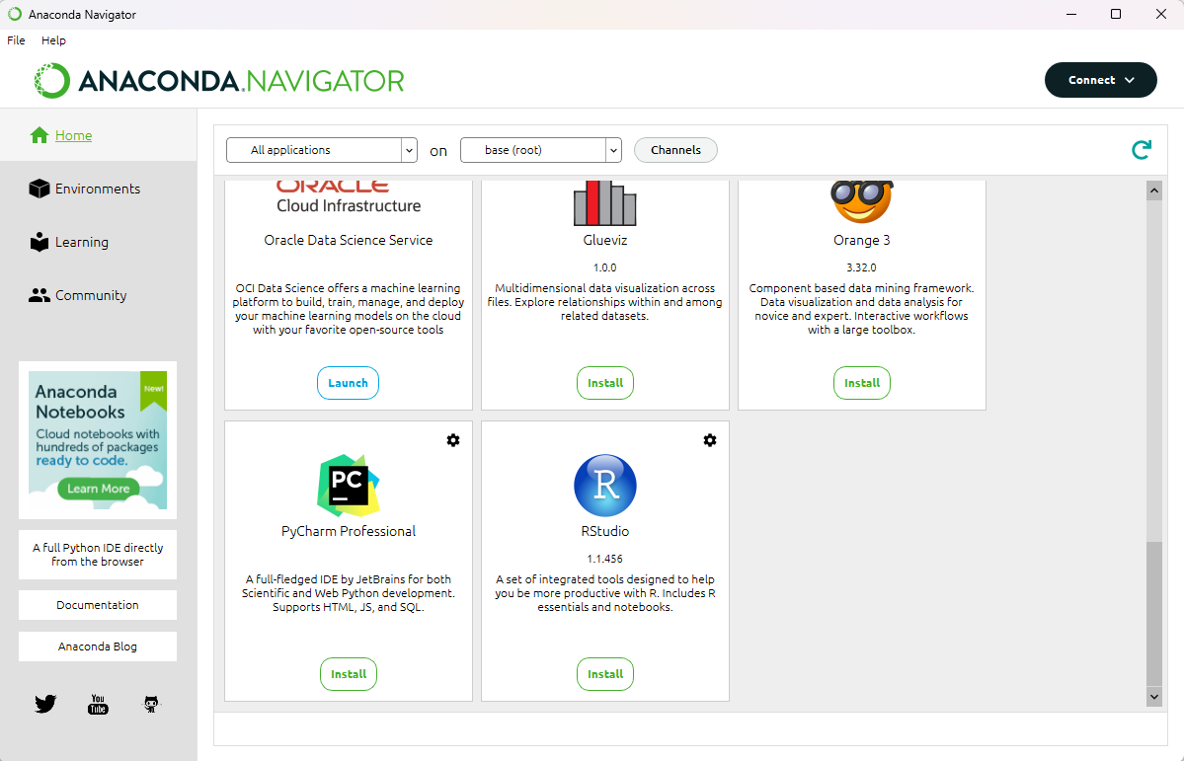

RStudio example

- Download the file “Titanic Exploration.Rmd” in Brightspace and open it with RStudio.
- Rmd is an extension for R Markdown file.
  - It contains YAML (yet another markup language) metadata, Markdown-formatted plain text, and chunks of R code that, when rendered using RStudio, combine to form a sophisticated data analysis document.

Lab

- This week you will go through the same Titanic Exploration example but using Python and Jupyter Notebook instead.
- Download the file “Titanic Exploration.ipynb” in Brightspace and make sure you can run the code in it.
- Check the difference in syntax between Python and R and see what you prefer. Observe the differences between methods and data types to achieve the same results.
- You won’t understand all the details. This is just to give an overview of how and what you can do with both languages.
comments
- Clear the console/terminal in R Studio , This sends a form feed character to the console, effectively clearing it.
  - >>run in the rstudio console >>> cat("\014")
- This will list all installed packages. Look for "languageserver" in the output.
  - installed.packages()[, "Package"]
    - installed.packages() returns a matrix where rows are package names and columns are details (Version, Priority, LibPath, etc.).
    - so you cannot directly use [, "ggplot2"], because "ggplot2" is not a column, it’s a package name (row name).
  - library(languageserver) >>load it > if installed no error
  - packageVersion("languageserver") >> which version
  - "ggplot2" %in% rownames(installed.packages())
  - packageVersion("ggplot2")
- To render the full .Rmd, you still need to run: to run a file
  - rmarkdown::render("your_file.Rmd")
- Pandoc error in VSC when run rmd file
  - > rmarkdown::render("Titanic Exploration - R.Rmd")
  - Error: pandoc version 1.12.3 or higher is required and was not found (see the help page ?rmarkdown::pandoc_ac_available
  - RStudio ships with Pandoc built in, but VS Code does not. That’s why you get the error. >> hence get error above in VSC
  - Quarto include pandoc - so don’t need to install pandoc if have quarto

Notes and example code – taken from Lab 1 file – Titanic Exploration- R.Rmd

Summary
- Performing a summary on the entire dataset is always a good place to start when cleaning data
    - ```{r}
    - summary(data)
    - ```

Convert a data type
    - ```{r}
    - data$Survived <- as.logical(data$Survived)
    - data["Survived.logical"] <- list(NULL)
    - ```

Character data
- is the *R* equivalent to what most programmer's would think of as *strings*
    - ```{r}
    - data$Name <- as.character(data$Name)
    - summary(data$Name)
    - ```

Factor
- Convert the `Name` feature to a **factor**. Thus, when we ask R to give us a summary of the `Name` feature we see a list of all of the unique passenger names, and the number of times each appears in the dataset. This would be very handy for something like *Genre* in a movie collection, as it would allow us to see how many of each type of movie we had, but it doesn't make much sense for Names
    - ```{r}
    - # By passing in maxsum=5 I'm telling R to show me no more than 5 unique values.
    - data$Name <- as.factor(data$Name)
    - summary(data$Name, maxsum=5)
    - ```

Factor Data –
- The **factor** datatype makes much more sense for this feature “sex”
    - ```{r}
    - summary(data$Sex)
    - ```
    - ```{r}
    - data$Sex <- as.factor(data$Sex)
    - summary(data$Sex)
    - ```

Factorign but with Order – i.e. First, second , third
    - ```{r}
    - ?factor
    - ```
  - We can look at the manual for the factor function by typing a question mark into the console followed by the function name. We can see from the output that the `factor()` function allows us to specify both the labels (human-readable text) and the levels (numbers reprenting the ordering between items). Notice that when we want to pass multiple values for `levels` and `labels` we use the `c()` (*combine*) function to combine the values into a single list. By specifying an ordering between the different categories (or to speak in R's language, **levels**) we allow R to be more intelligent when displaying graphs *etc.*
    - ```{r}
    - data$Pclass.factor <- factor(data$Pclass,
    - order=TRUE,
    - levels=c(1.0,2.0,3.0),
    - labels=c("1st Class", "2nd Class", "3rd Class")
    - )
    - ```

Integer and Numeric Data
  - Integer and Numeric Data
  - Summary of ‘age” feature in file
    - ```{r}
    - summary(data$Age)
    - ```
  - Age has been recognised as a number. Notice, however, that the youngest passenger is 0.42 years old. This is strange. And it looks like the majority of ages are simply specified to the year.
  - We can use the [modulus (%%) operator](https://en.wikipedia.org/wiki/Modulo_operation) to to remove everything to the left of the decimal point The statement `12 %% 5` instructs R to divide 12 by 5 and return only the remainder
  - If we convert the `Age` feature to a **factor**, then *R* will keep track of each unique value for us. If we summarize the data *as a factor* we'll get a breakdown of each of the distinct values. Notice that even though we're converting `data$Age` to a factor we're not assigning the result back to our table so our data is left unchanged
    - ```{r}
    - summary(as.factor(data$Age %% 1))
    - ```
  - We can see 25 ages have been specified to at least 1 decimal place and 862 have not. This looks like inconsistency in data collection. We can simply remove the decimal place to fix this, effectively rounding everything down.
    - ```{r}
    - data$Age <- as.integer(data$Age)
    - ```

Visualising the Data

Histograms
- histogram takes a numeric variable on the x axis, groups similar values together into *bins*,
- ggplot to put Age on the X axis, andrepresent whether or not a passenger survived by colour (fill). We're then specifying that we want it to create a histogram for us, and finally, we're using the `labs()` (labels) function to specify a title for the graph.
  - ```{r}
  - ggplot(data, aes(x=Age, fill=Survived)) +
  - geom_histogram() +
  - labs(title="Survival Rate by Age")
  - ```
- Notice the warning message from R in the console. We didn't tell R how
- wide we want our bins to be. so it's defaulted to using 30 bins.
- For Loop
  - For Loop to change bin width
    - ```{r fig.height=1.75, fig.width=3.5}
    - # This for loop is telling R to create this plot with different binwidths.
    - # 1:10 is a shorthand way of writing c(1,2,3,4,5,6,7,8,9,10)
    - for (binwidth in 1:10) {
    - # Because we're inside a for loop, we now need to explicitly tell ggplot
    - # to draw our plot by using the print() function
    - print(ggplot(data, aes(x=Age, fill=Survived)) +
    - geom_histogram(binwidth=binwidth) +
    - labs(title=paste("Survival Rate by Age, Binwidth", binwidth)))
    - }
    - ```
  - Narrower bins give more precise visualizations but if they're too narrow they just add noise to the graph. Pick a bin-width that shows an interesting trend without being too noisy (random ups and downs)

Bar Charts
- Visualize counts of data broken down by category.
- The `scale_fill_discrete` function allows us to control the way fill is used within the graph. By passing explicit values for labels we can change the legend text. Also, by adding `position="dodge"` to the `geom_bar` function we tell R to make the bars sit beside (rather than on top of) one another.
    - ```{r}
    - ggplot(data, aes(x=Sex, fill=Survived)) +
    - geom_bar(position="dodge") +
    - scale_fill_discrete(name = "Outcome", labels = c("Did Not Survive", "Survived")) +
    - labs(title="Passenger Survival by Gender")
    - ```

Faceting
- A way to split a dataset into subsets and draw separate plots for each subset, arranged in a grid
- Facets allow you to combine multiple graphs filtered on one or more categories, or **factors**.
- To see how Age, Passenger Class and Gender interacted to influence survival. We start by defining a single histogram plot which shows how the survival rate varied with age. We're going to repeat this plot for each combination of class and gender. The facet_grid function allows us to specify which variables we'd like to split our data on.
    - ```{r}
    - # Make sure you've loaded the `lattice` module
    - # We did this with our library(lattice) at the top of the script

    - ggplot(data, aes(x=Age, fill=Survived)) +
    - geom_histogram(binwidth = 5) +
    - facet_grid(Sex ~ Pclass) +
    - ggtitle("Titanic Survival by Age, Gender and Class")
    - ```

Computed Features
- Categorize our passengers into children and adults. By using the dollar operator we're creating a new feature on our dataset called `IsChild`. `IsChild` will be true if `Age` is less than 16, false otherwise. Create that value and plot it….
    - ```{r}
    - data$IsChild <- data$Age < 16

    - ggplot(data, aes(x=IsChild, fill=Survived)) +
    - geom_bar(position="dodge") +
    - scale_x_discrete(name="Child/Adult", labels=c("Adult", "Child")) +
    - scale_fill_discrete(name = "Outcome", labels = c("Did Not Survive", "Survived")) +
    - labs(title="Titanic Survival Rate of Adults/Children")

    - ```

Formula
- The tilde (\~) operator in R denotes a formula. We can read the example below as 'Sex' by 'Class' Try it out and then see what happens if you swap the formula around

Python vs R
- .Rmd > extension for R markdown file
  - Contains yaml metadata
  - Chunks of R code
- Ipynb
  - Convert t Boolean using astype method
  - Iloc = method to returna slice of the dataframe
    - `df.iloc[:,0]`
    - Gives all the rows and first column only.
  - df.iloc[:,0] = df.iloc[:,0].astype(bool)
  - df.describe(include="all")
  - set ‘Age’ to be an integer ‘int64’ using astype =? No more decimals
    - df["Age"] = df["Age"].astype('int64')

iloc index based selection vs column name
Feature | df["Age"] = ... | df.iloc[:, 0] = ...
Access type | Label-based | Position-based
Readability | ✅ clear | ❌ ambiguous
Safe against column reorder | ✅ yes | ❌ no
Use case | When you know the column name | When writing generic code or using column index
Typical usage | df["Age"] = df["Age"].astype(int) | for i in range(df.shape[1]): df.iloc[:, i] = ...

- Summary (R) vs describe (python)
  - what happens if you remove the `include="all"
  - df.describe(include="all")
  - describe only sumarises numeric columns…
  - summarizes all columns, regardless of type (numeric, categorical, object, datetime, boolean, etc
  - Both summary() (R) and describe() (pandas) give quick dataset overviews, but they behave a bit differently.
  - Summary >>

Feature | R: summary() | Python: df.describe()
Default scope | All columns | Only numeric
Numeric stats | Min, 1Q, Median, Mean, 3Q, Max | count, mean, std, min, 25%, 50%, 75%, max
Categorical | Shows full frequency table | Only unique, top, freq
Output format | Human-readable, per column | Tabular (matrix-like)
Extensibility | Works on many object types (lm, glm, etc.) | Mostly for DataFrames/Series

Visualization
- Histogram
  - plot an histogram of *Age* separated by *Sex*. For that we will need to use the `pivot` method to get only the data we are interested in plotting, or in this case the *Age* feature separated by females and males.
  - using the `plot` method of the Pandas module.
    - df.pivot(columns="Sex", values="Age").plot.hist(bins=30, stacked=True)
  - histogram with different binwidths
    - In Python we can do that by passing the number of bins or a sequence representing the bin edges. In this example we are going to use the sequence option.
  - Generate a sequence we are going to use the `range` function from the built-in Python functions. Its header is defined as `range(start, stop, step)`, so given a start and stop values it creates all the numbers in the sequence between them with step `step`. For example `range(0, 12, 2)` will generate the sequence `0, 2, 4, 6, 8, 10`
  - It uses a **for** loop to generate sequences of bin edges with different steps

    - for binwidth in range(1,10):
    - df.pivot(columns="Sex", values="Age").plot.hist(bins=range(min(df["Age"]), max(df["Age"]) + binwidth, binwidth), stacked=True)
- Barcharts
  - first we add the axes to the figure, then we add one bar, then the legend, etc. It offers a lot of customisation, allowing us to define how the graph will look in detail.
  - # plt refers to the `matplotlib.pyplot` module that
  - # we imported in the first cell. Here we are creating a figure
  - # with the figure method.
  - fig = plt.figure()

  - # Add axes with the add_axes method to the figure object.
  - # This defines the dimensions [left, bottom, width, height] of the
  - # new axes as fractions of figure width and height. It does not
  - # define the actual size of the figure. Here, left and bottom are at (0,0)
  - # and width and height have proportion 1 to the figure size, so it is a square.
  - # Try changing the third value to 0.5 and see what happens.
  - ax = fig.add_axes([0,0,1,1])

  - # First, we filter the data according to the criteria we want, i.e. male and survived.
  - # To filter, we are applying some conditionals to the Pandas dataframe.
  - female_died = df[(df.Sex == "female") & (df.Survived == False)]
  - female_survived = df[(df.Sex == "female") & (df.Survived == True)]
  - male_died = df[(df.Sex == "male") & (df.Survived == False)]
  - male_survived = df[(df.Sex == "male") & (df.Survived == True)]

  - # To count, we are using the `len` (short for length) method of Python.
  - # The code below starts by adding two bars to the axes using the bar method and
  - # associating to each bar the data we want to plot.
  - # It follows then by adding the legend, title, y label, x ticks, and x ticklabes.
  - # Finally, once we have defined everything we are calling `plt.show` to plot the graph.
  - # Try to investigate the code below and see what it does.
  - # Perhaps run some smaller parts in different cells and see how they work.
  - ax.bar([0, 1], [len(female_died), len(male_died)], color = 'b', width = 0.25,)
  - ax.bar([0.25, 1.25], [len(female_survived), len(male_survived)], color = 'r', width = 0.25,)
  - ax.legend(labels=['Did not survive', 'Survived'])
  - ax.set_title('Passenger survival by gender')
  - ax.set_ylabel('Count')
  - ax.set_xticks([0.125, 1.125])
  - ax.set_xticklabels(["Female", "Male"])
  - plt.show()
- Facets
  - Same as in R
  - we are going to use the `subplot` method of `matplotlib` that allows us to plot multiple graphs in a single figure. To filter the data according to the combination of features we are interested in, we are running two nested loops that will iterate over the values of *sex* and *pclass*. Note that this time we are actually defining the figure sizes before plotting them. S

    - sex = ["female", "male"]
    - pclass = [1, 2, 3]
    - index = 1
    - nrows = 1
    - ncolumns = 6

    - plt.figure(figsize=(50, 10))

    - for p in pclass:
    - for s in sex:
    - plt.subplot(nrows, ncolumns, index)

    - data = df[(df.Sex == s) & (df.Pclass == p) & (df.Survived == False)].Age.values
    - plt.hist(data, bins=range(min(data), max(data) + 5, 5))

    - data = df[(df.Sex == s) & (df.Pclass == p) & (df.Survived == True)].Age.values

    - plt.hist(data, bins=range(min(data), max(data) + 5, 5))

    - plt.legend(labels=['Did not survive', 'Survived'])
    - plt.title(s + " " + str(p) + " class")
    - plt.xlabel("Age")
    - plt.ylabel("Count")
    - index += 1

    - plt.tight_layout()
    - plt.show()

Questions?

Week 2 – Review Python and practice

Indicative schedule

Week 1 | Set up environment and R notebook
Week 2 | Review Python and practice
Week 3 | Review R, importing data
Week 4 | Intro SQL and aggregate queries
Week 5 | Databases and scripting languages (To be submitted)
Week 6 | Interpreting Data (summary statistics, data visualisation)
Week 7 | Review week
Week 8 | Data manipulation in R
 | Pandas and Numpy
Week 9 | Data visualisation in Python
 | Data processing (regular expressions)
Week 10 | Audio data (R and tuneR) (To be submitted)
Week 11 | Image data (Python and skimage) (To be submitted)
Week 12 | Time series (Python and Pandas)
Week 13 | Working on Assignment
 | Assignment deadline

Overview

- Python
  - Data types
  - Functions
  - Lists
  - Sets
  - Dictionaries
  - Tuples
  - Strings

Before you start
- You should be familiar with at least one general-purpose language
  - Functions / Methods
  - Flow-Control (if/else and loops)
  - Variables
  - Types
- We are going to see a very quick introduction. More training is available on the datacamps provided.
  - Intro to Python for Data Science
  - Intermediate Python

Datacamp 

- You can access DataCamp courses for extra practice (that is highly recommended)
- Please create an account with the @mytudublin.ie domain to have free access to all courses through the link below
Link to register on DataCamp
- Some courses that might help you in the first weeks (not all there is covered in this module):
Intro to Python for Data Science
Intermediate Python
Introduction to R
Introduction to importing data to R
Web scraping in R

Eamonn: comment to do datacamp courses to get up to speed

Data Types

Python Built-in Data Types
- Integer: Whole numbers (can’t contain decimals)
- Float: Any number (can contain decimals)
- Boolean: Either True or False
- String: Text
- List: A collection of values arranged one after the other
- Set: A collection of values with no duplicates
- Dictionary: A collection of values which can be accessed with lookups
  - Comment > (also known as associative arrays or has maps in other languages)
- Tuple: Similar to a list, but with a fixed size and order
  - Comment > same as lists but immutable and can’t be changed

Checking and Converting Types

- Usually you don’t need to worry about data types.
  - Comment > don’t need to specify when creating… that’s good and bad…
  - Comment > As we don’t types python as “introspection”
  - Comment > Opens possibilities – we can create functions based on type in the arguments
    - In java have to clearly specify
- If you need to check you can use the type() function
- This is called introspection, meaning that a variable might change its type, and you can check that during runtime.
- Comment > Python is Object orientated
- Comment > we wont’ be using classes in this course tho

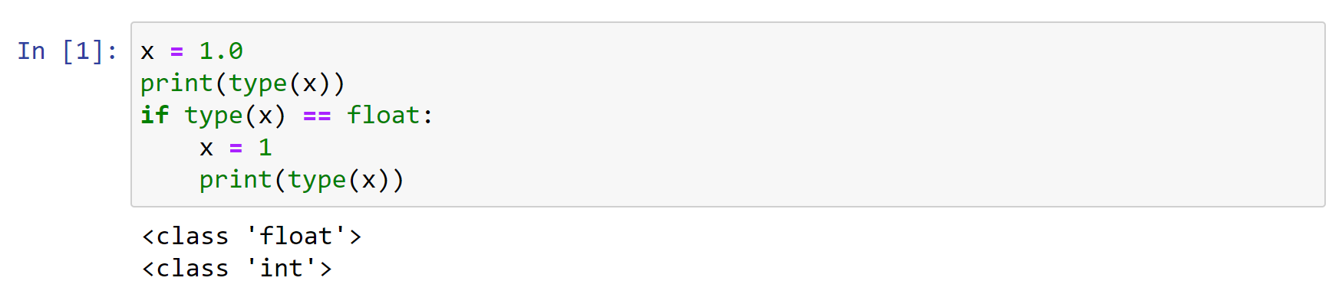

Functions

Python functions
- Comment > Is A function like in any other language
- A Python function is a block of code that returns something and that we can run later in the script
- It allows us to reuse code
- Functions can take zero or more parameters

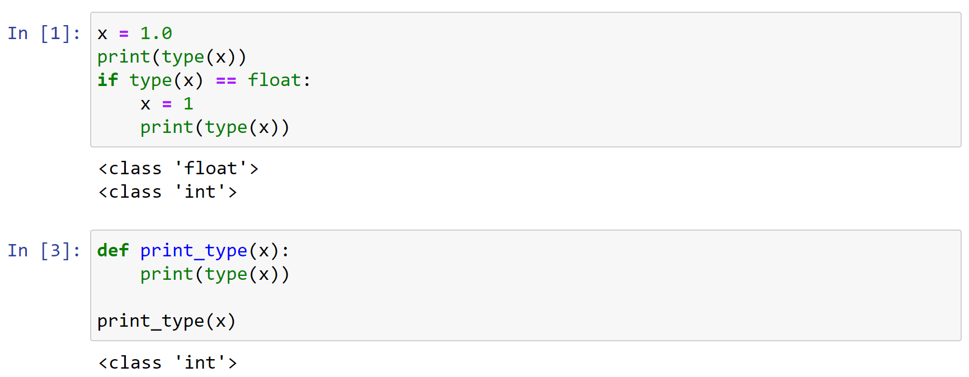

‘’’ py
x = 1.0
print(type(x))

if type(x) == float:
x=1
print(type(x))

def print_type(x):
print(type(x))

print_type(x)
‘’’
‘’’py
Comment >> can annotate to specific a type. We want two floats but we cannot enforce that….
>> comment : Also indicate we want to eturn a float, but we can’t enforce and still works witn ints
def add_values(a: float, b: float) -> float:
return a + b
def print_type((x: int))
print(type(x))

x= 1
print_type(x)
print(add_values(5, 4))

- comment >>> repeat with strings >>> works and concatenates >>> only works because of introspection i.e. we cannot force the type
- if int pr float => ads
- if str => concatenates
- (checks type before does work)
- If do for mixed tupe i.e. str and in => get error as can’t add str and int/float

x= 1
print_type(x)
print(add_values(“5”, “4”))

‘’’

Python functions
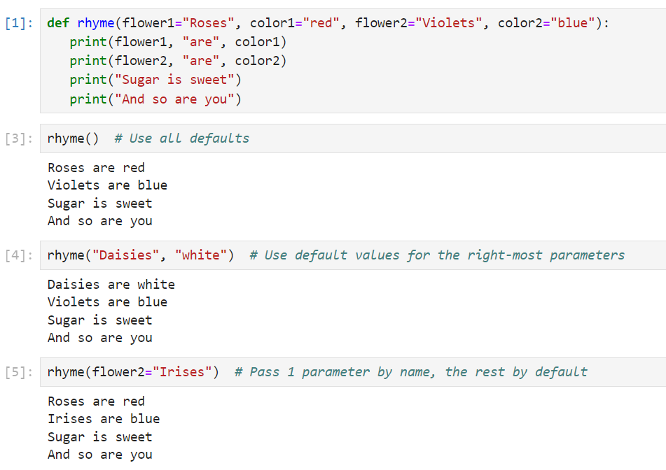
‘’’py
Def rhyme (flower1=”Ross”, color1=”Red”, flower2=”violets”, color2=”blue”)
Print(flower1, “are”, color1)
Print(flower2, “are”, color2)
Print(“sugar is sweet”)
Print(and so are you”)

rhyme()

‘’’

Comment > different ways tp pass a parameter in python > will sue a lot of functions

Lists

What is a Python List?
- A list lets us pack lots of values into a single variable
- Similar to an array in most other languages
- We can use loops to process each item in an array
- Or we can retrieve items individually by index
- Python allows you to store different data types in a single list

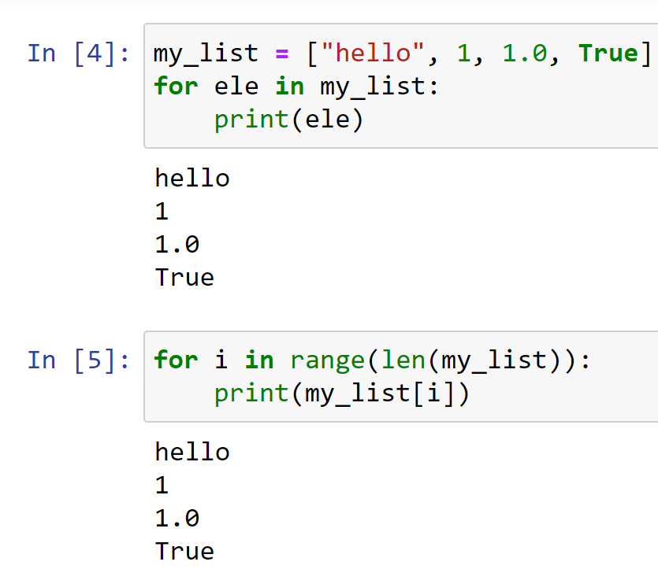

‘’’py
my_list = ["hello", 1, 1.0, True]

for ele in my_list:
print(ele)

for i in range(len(my_list)):
print(my_list[i])

my_list.append("banana")
print (my_list)

my_list.remove("banana")

‘’’

Working with Lists

- We can create a list in Python using square-bracket notation
- We can add items to the end of a list using the list append() method
- We can remove items using the remove() method
  - This removes the first occurrence only
  - If the item doesn’t exist in the list we get an error

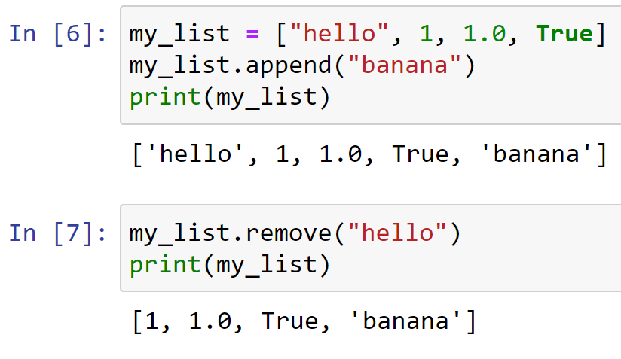

Accessing Items by Index

- Each item in a list has an index, or position, within the list
- Python indexes are zero-based
  - This means the first item has an index of 0
  - The second item has an index of 1
- We can use the index to retrieve an item from a list

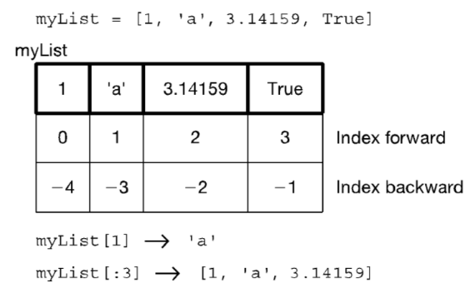

Inserting Items
- We can insert an item in a specific position using the list insert() method.
- 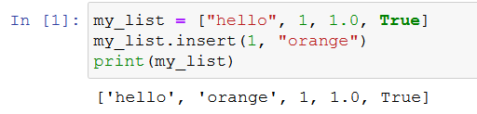
- Or add something in the last position using append()

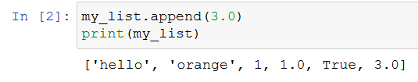
- Comment >
- can add two lists and it appends second list , can multiply a list also get trbles lists etc
- Result not stored any where > just shown on screen when sue print
- Check how big using “len”
- Use “in “ to see fi somethgin in the lisr

if “hello” in double_list
print
‘’’

List operators

- Concatenate +
- Repeat *
- Indexing the [ ] operator
- Slicing [start:end:step] (end not inclusive)
- Membership (the in operator)
- Length len (the length operator)

Lists of lists

What is the second element (index 1) of that list? Another list.
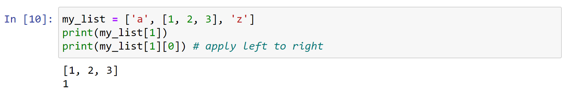

Some list methods
- A list is mutable and can change
  - my_list[0] = 'a' #index assignment
  - my_list.append()
  - my_list.extend()
  - my_list.pop()
  - my_list.insert()
  - my_list.remove()
  - my_list.sort()
  - my_list.reverse()
- Python documentation:
  - https://docs.python.org/3.1/tutorial/datastructures.html

List comprehension

- List comprehensions are a very readable way of creating lists (once you get used to them)
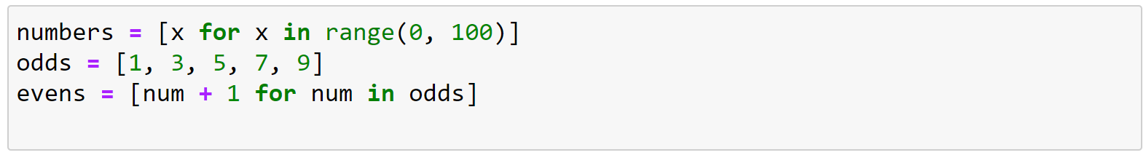
- Comment >
- short way to create list in python
- Can add condition to end i.e. if % 2 == 0 (if value of x is even….) add it to the list
- Can add some operation to the value we are collecting x + 1 ( now even list becomes odd list
- Can use for tuple and dictionaries aswell… not just lists
- Read it from the RHS!!!

‘’’py
# list comprehensions
numbers = []

for x in range(0,100):
numbers.append(x)

print(numbers)

numbers = [x for x in range(0,100) if x % 2 == 0]
print(numbers)

numbers = x+1 for x in range(0,100) if x % 2 == 0)

numbers = [x for x in range(0,100)]
odds = [1, 3, 5. 7, 9]
evens [num + 1 for num in odds]
‘’’

Sorting Lists
- We can use the list sort() method to sort a list in ascending order
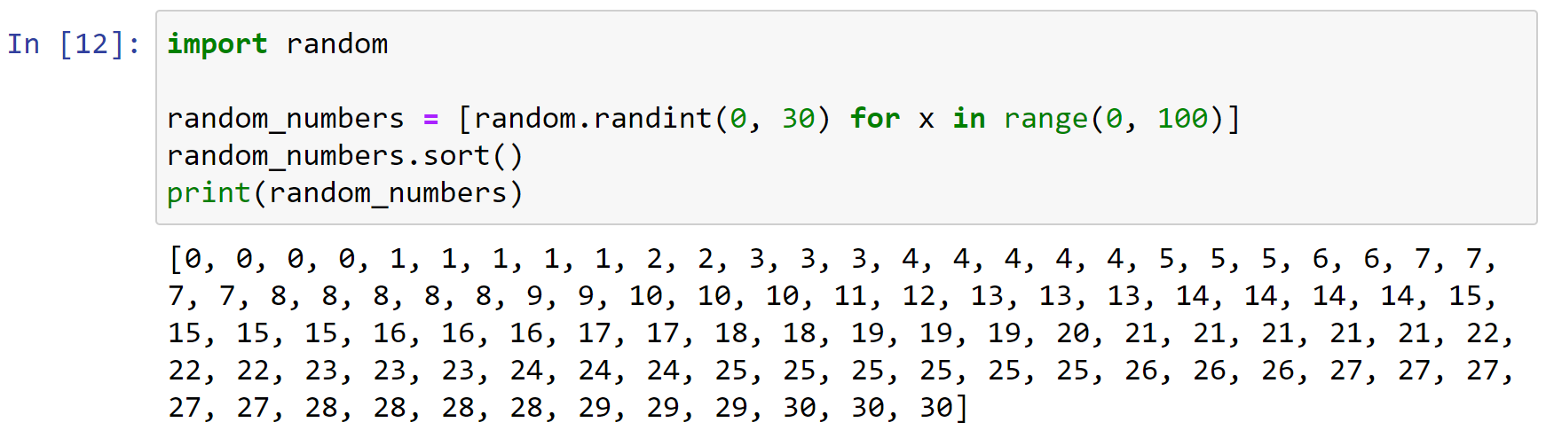

‘’’py
Import random
random_number = [random.randint(0,30) for x in range(0,100)]
random_numbers.sort()
print(randome_numbers)

‘’’

Tuples

- Tuples are immutable sequences
- They are printed with (,) and similarly to lists can have various length
- Comment >
- same as lists except immutable - -i.e. cannot be changed…
- We know it’s a tuple because it has no brackets and there is a comma
  - This is a tuple with two values… (below
  - Access same as with lists….
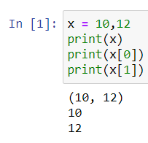
- Not a tuple, multiple assignment
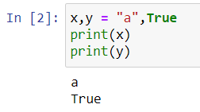

- For the most part, tuples work exactly like lists
- However, an immutable list gives you a data structure with some integrity, some permanent-ness if you will
- You know you cannot accidentally change one.

Tuples – 2
- Everything that works with a list works with a tuple except methods that modify the tuple
- Thus indexing, slicing, len, print all work as expected
- However, none of the mutable methods work: append, extend, del

- For tuples you can think of a comma as the operator that makes a tuple, where the ( ) simply acts as a grouping:

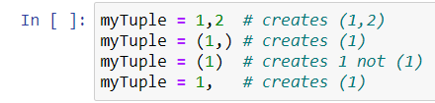

- Suppose my_tuple = (1,2,3,4,5)
  - Concatenate: my_tuple + my_tuple
  - Repetition: my_tuple * 3
  - Index access: my_tuple[1]
  - Index access: my_tuple[-1]
  - Slice: my_tuple[:3]
  - Slice: my_tuple[1:3]
  - Membership: 2 in my_tuple
  - Membership: 10 in my_tuple
  - Length: len(my_tuple)
  - Minimum: min(my_tuple)
  - Maximum: max(my_tuple)
  - Sum: sum(my_tuple)
  - Comparison: (1,2,3) > (1,2,1)

/’’’ py
Is one tuple greater than another / checks values individually, 1 vs 1 , 2 vs 2 , 3 vs 2)

Print(1, 2, 3) > (1, 2, 2)
TRUe

‘’’’’

Sets

Python Sets
- A python set is similar to a list but
- Sets cannot contain any duplicates
- Sets are unordered (no index)
- Sets follow the rules for mathematical Set Theory
  - https://www.probabilitycourse.com/chapter1/1_2_0_review_set_theory.php
- Checking if an item exists in a set is very fast

- Comment
  - To find intersection
  - Union etc
  - Very fast to check if item tina set
  - Cn create set from anythgin caniterate over
  - Curly braces =>> a set
  - Can create with dups but wil only keep unique values
  - To find unique avleus in a list or tuple >>> create a set out of it and will get al unique elements
  - Move to sets and use intersectin method
  - Use sets for their methods…. In / not in / union / intersetction / difference / symmetric.difference (union minus the intersection)
  - .differemce >>> elements in set 1 not in set 2 >> order matters difference between which set and which…

Creating a set
- Sets can be created in one of two ways:
  - constructor: set(iterable) where the argument is iterable
my_set = set('abc')
print(my_set) 🡪 {'a', 'b', 'c'}
  - shortcut: {}, curly brackets where the elements have no colons
my_set = {'a', 'b','c'}
- Duplicates are automatically removed
my_set = set("aabbccdd")
print(my_set) 🡪 {'a', 'c', 'b', 'd'}

Set Operations
- len(s) → Number of elements in the set
- x in s → test if set s contains value x
- x not in s → the opposite of x in s
- s.union(t) → new set with everything in s and everything in t
- s.intersection(t) → new set containing elements in both s and t
- s.difference(t) → new set with elements in s but not t
- s.symmetric_difference(t) → new set with elements in s or t but not both

Check yourself

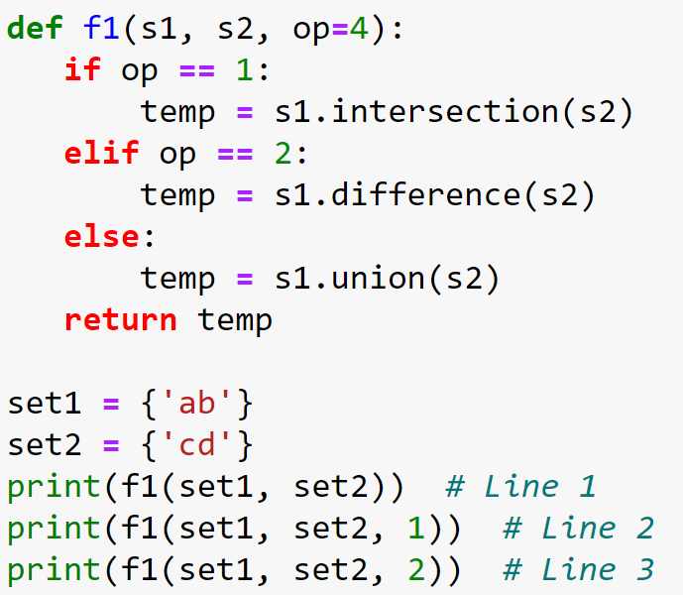

Q: What is the output of (a) Line 1, (b) Line 2, and (c) Line 3

‘’’py
def f1(s1, s2, op=4):
if op==1:
temp = s1.intersection(s2)
elif op==2:
temp = s1.difference(s2)
else:
temp = s1.union(s2)
return temp

set1=(set('ab'))
set2= set('cd')
print(f1(set1, set2))
print(f1(set1, set2, 1))
print(f1(set1, set2, 2))

‘’’’’

Dictionaries

Python Dictionaries

- In data structure terms, a dictionary is better termed an associative array, associative list or a map.
- You can think if it as a list of pairs, where the first element of the pair, the key, is used to retrieve the second element, the value.
- Thus we map a key to a value
- Use the { } marker to create a dictionary. Use the : marker to indicate key:value pairs. Separate elements by comma.
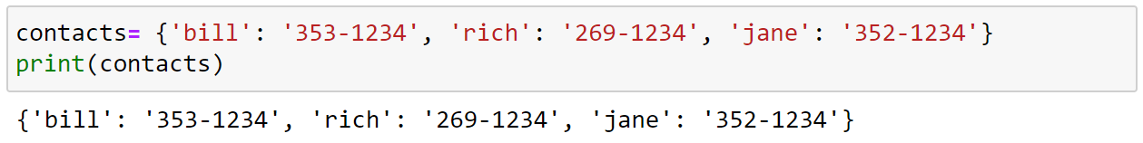

- Key must be immutable
  - strings, integers, tuples are fine
  - lists are NOT
  - cannot have repeated keys
  - need to eb unique so we can access the value…
  - key can be a tuple….strings/int
  - keys are collections
- Value can be anything
- Keys can not be repeated in the dictionary
- Dictionaries are collections but they are not sequences (such as lists, strings or tuples)
- There is no order to the elements of a dictionary
  - in fact, the order (for example, when printed) might change as elements are added or deleted
comments

‘’’ py

‘’’’

Dictionary operations
- Comment
- Good to know operations!!!

- key in d: returns True if the item is found, False otherwise
- d.get(key, [default value]): gets the item with the given key. If the key doesn't exist this will return default value, if you've given one, otherwise it will error
- d[k] = v: adds v to the dictionary with the key k
- d.keys(): returns the set of all keys in the dictionary d
- d.values(): returns a list of all values in the dictionary d
- d.items(): returns a list of all key-value pairs in the dictionary d
- del d[k]: removes the item with key k from the dictionary

- comment
- we know it’s a dict because of curly bracktes and colon…

Looping through a Dictionary

- We can loop through a dictionary just like we can loop through a list
- The keys() method returns all of the keys in the dictionary
- The values() method returns all of the values in the dictionary
- The items() method returns both keys and values for the dictionary

Looping through a Dictionary – 2

‘’’py

Contacts = {'bill': '333-1234', 'rich' : '269-345', 'jane': '5423-2345'}
print(Contacts)

for key in Contacts:
print(key)

for key, value in Contacts.items():
print(key, value)

for value in Contacts.values():
print(value)

‘’’
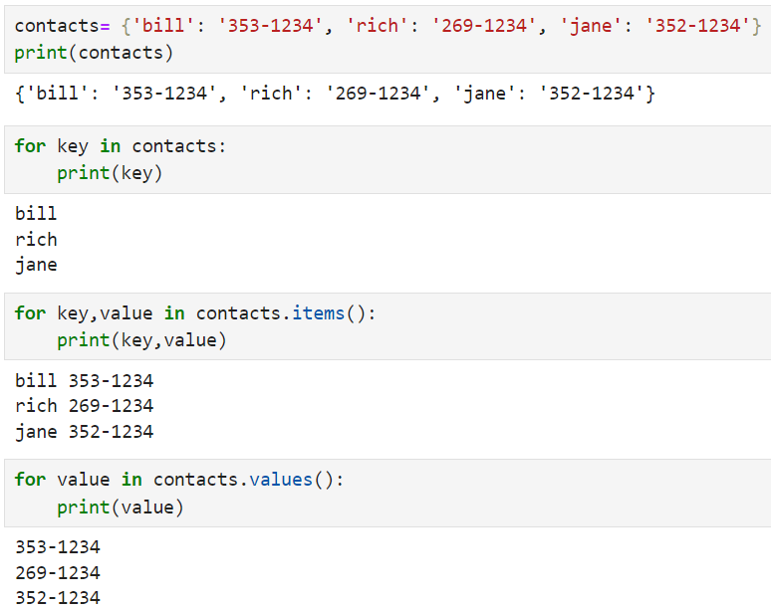

Check yourself
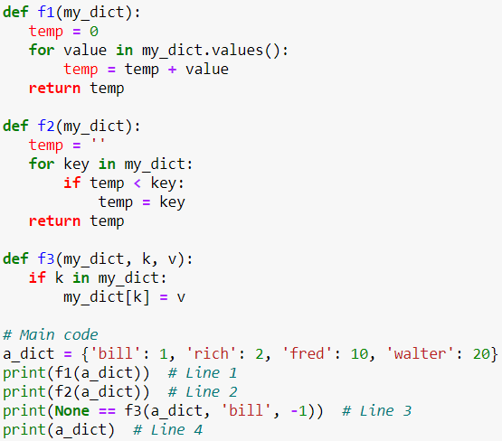

Question : What is the output of (a) Line 1, (b) Line 2, (c) Line 3, and (d) Line 4?

‘’’py
def f1(my_dict):
temp=0
for value in my_dict.values():
temp = temp + value
return temp

def f2(my_dict):
temp=''
for key in my_dict:
if temp < key:
temp=key
return temp

def f3(my_dict, k, v):
if k in my_dict:
my_dict[k] = v

# main
a_dict={'bill': 1, 'rich': 2, 'fred': 10, 'walter':20}
print(f1(a_dict)) # Line 1 >>> answer adds them up >> 33
print(f2(a_dict)) # Line 2 >> answer >>> empty string is shorter than Bill >> then check 2nd one >> Bill smaller than rich >> B is smaller than R >>>> Rich smaller than Walter it is >>>
all string s with letters… greatest one is walter as no name after “W”
print(None == f3(a_dict, 'bill', -1)) #Line 3 >> not returngin anything >> no key word “return” >> if not return word “None”…
is a side effect of F3 >> passing a dictionry >> check si K is in dict?>> then assign value of Bill to be -1…so before we had Bill1 >>> now it = -1 >>>
print(a_dict) # Line 4 >> answer >>> Bill : -1 >> reason to change and reason not to change >>>> not change thinking these operations not reflect on main scope…. When passing a dict we’re apssing a reference >> when we do this kind of operation here we are changing a value…

mutable change > without changgin associaraion it changes…. Don’t [ass by reference / copy
Passing lists in dicts if passing mutable changes in functinos this will also be reflected outside of the function…

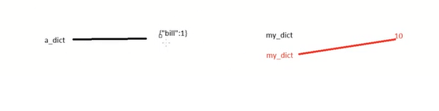

‘’’

Strings

Strings
- A string is a sequence of characters
- In Python it is enclosed between ' ' or '' ''
- The exact sequence of characters is maintained
"Hello" or 'Hello' - OK
"Hello' - Error! >> not a string mixed brackets
- Comment >
- same as a list except all characters
- Strings are immutable

String Access

- Essentially a string is a list of characters, so you can access a string by index
- As with lists, slices and negative indexes work on strings

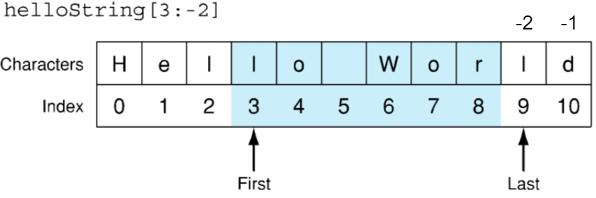

String methods

- We can convert strings to lower and upper case using the upper() and lower() functions
- We can search for text within a string using the string find() method
- We can replace text within a string using the replace() method

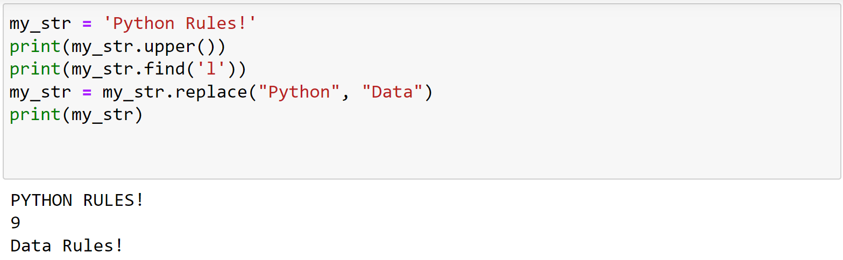
- Comment
- List.append > changes list
- But
- Str.Upper doesn’t change the string value…
- Returns a str that ahs replaced the value…

Split and join

- The split() function converts a string to a list using a specified delimiter
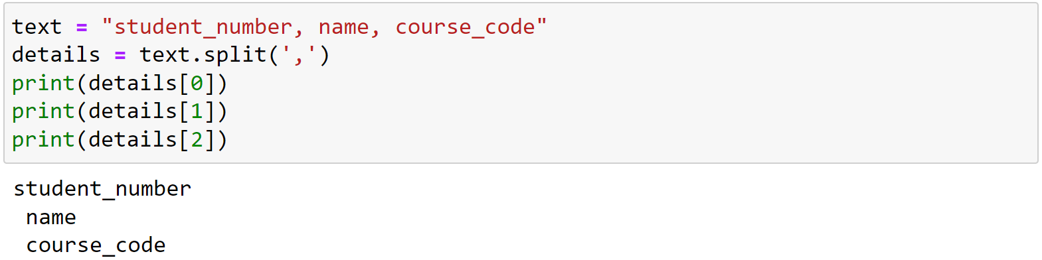
- The join() function converts a list to a string using a specified delimiter

- Comment >>>
- Common for csv file
- Split will return a list
- Can join back using join method in strings…
- Very common in csv >> split > loop over values > join back

‘’’py
text = "standard_number, name, record"
print(text)
details = text.split(",")
print(details)
details.sort()
print(details)
text=','.join(details)
print(text)

‘’’

Advanced String Manipulation

- String manipulation is very important, particularly in Natural Language Processing
- Regular Expressions (RegEx) is a mini-language used for advanced string matching and replacing
- Comment >> on wekk 9 >> regex
- Text Preprocessing is very important in NLP and Python provides lots of libraries to help you do it.
- Comment >> probably need a course just on NLP
- All of this is for another day though!

Summary

- Python
  - Data types description
  - Function syntax and how to create
  - Lists
    - How to create, access, loop through it, remove items, list operators, list methods
  - Sets
    - How to create and methods
  - Dictionaries
    - How to create, access keys and values, loop through it
  - Tuples
    - How to create, operators and methods
  - Strings
    - How to create, access and use some of its methods
- Next week: R data structures and data importation

Questions?

Lab
- Python practice exercises in Jupyter Notebook

Week 3 - Review R, importing data

Week 4 - Intro SQL and aggregate queries

Links and Rerences
- General – from early chat
  - XLS Semester with all courses and all links > https://docs.google.com/spreadsheets/d/1lflFEgHnTlqOd_ZDnIWwgpTnMqc95MPo/edit?gid=1407562868#gid=1407562868
- week 1 >>
  - Content:
    - ppt 0 + ppt 1 + titanic files https://drive.google.com/drive/folders/1FlUlyncqCDS0dE_FJcR_9ICcGoVEnnS7?usp=sharing
  - Labs
    - R
      - R Markdown have a look [here](https://rmarkdown.rstudio.com/lesson-1.html )
      - [Titanic Dataset](https://web.stanford.edu/class/archive/cs/cs109/cs109.1166/stuff/titanic.csv
      - [modulus (%%) operator](https://en.wikipedia.org/wiki/Modulo_operation
      - [kaggle titani notebook](https://www.kaggle.com/romabash/titanic-data-visualization#3.-Look-at-Survival-Rate-by-Ticket-Class
    - Ipynb
      - [pandas](https://pandas.pydata.org/docs/)
      - "source": ["url=\"https://web.stanford.edu/class/archive/cs/cs109/cs109.1166/stuff/titanic.csv\"\n
- pandas documentation linked [here](https://pandas.pydata.org/docs/index.html
- matplotlib documentation [here](https://matplotlib.org/stable/contents.html )
- jyupyter notebooks - [here](https://www.datacamp.com/community/tutorials/markdown-in-jupyter-notebook)

- Week 2 >> Content > ppt 2 + python practice
  - https://tinyurl.com/5b3p77v4
- General Course
  - • DIT MSc Website >> https://sites.google.com/view/mscincomputersciencetu059tu060/home
  - • Module Catalogue >> https://sites.google.com/mydit.ie/msccomputing/home
  - • MSc Dissertation Website >> http://brightspace.tudublin.ie/
  - • Team Project Website >> https://sites.google.com/mydit.ie/msccomputing/home
  - • MSc Blog >> http://ditmsc.blogspot.com/
  - Notice Board – blogspot - or all MSc/PgCert in Computer Science Students - TU Dublin - TU059/TU060/TU256
    - https://ditmsc.blogspot.com/2020/?m=1

Week 1
- Week 2 >> https://tinyurl.com/5b3p77v4

Books
  - Wickam & Grolemund, R for Data Science, O’Reilly Press, 2016. Free at https://r4ds.had.co.nz/
  - Andrew O. Finley, Jeffrey W. Doser, Vince Melfi, R Programming for Data Sciences. 2020. Free at https://bookdown.org/rdpeng/rprogdatascience/
  - McKinney, Wes. Python for data analysis: Data wrangling with Pandas, NumPy, and IPython. " O'Reilly Media, Inc.", 2022. Open access HTML https://wesmckinney.com/book
    - Eamonn: This is book he recommends for more traditional book approach, he will take samples from here…

Week 1

Slide counts
- Week 1 =
  - Ppt 1 = 15 slides
  - Ppt 2 = 25 slides

Completed
- Week 1
  - Recording – there is no recording… didn’t record.. aid there was no content anyway
  - Content - completed
  - Labs and Exercises
- Week 2
  - Recording - competed
  - Content - completed
  - Labs and Exercises
- Week 3
  - Recording -
  - Content -
  - Labs and Exercises

Questions?
- eamonn : Will assessments need to eb done in python or R, or can we choose?
  - Where should I focus my time?
  - Comment> answer >> for assignemnts > use whatever language you prefer Ror Python….
- Eamonn: Is it easy to convert python / jupyter notebook to an R md file? Then convert to html (knit) so can publish standalone html in quarto?

